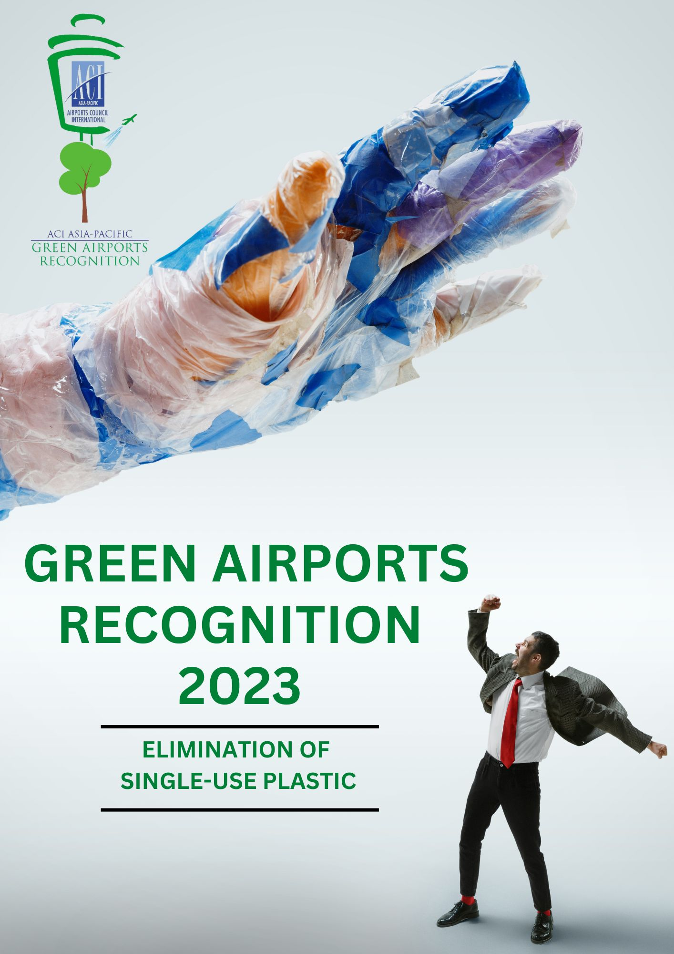
Part I- Programme Description

Background and Objective
The Green Airports Recognition promotes environmental best practices to minimise aviation’s impact on the environment and recognises airport members who have outstanding accomplishments in environmental projects.
This initiative allows airports to share environmental projects with other airports in the region and be recognised for their achievements.
Initiative Topics - Environment
The environmental field encompasses the following key themes, from which a topic will be selected for the Green Airports Recognition each year:
- Environmental Policy and Management (including green procurement)
- Noise
- Air quality
- Waste
- Water (including both municipal water usage and wastewater discharge)
- Energy
- Carbon
- Biodiversity
- Ground transportation
- Land & water contamination
- Others
Green Airports Recognition 2023 – Single-Use Plastic Elimination
Single-use plastic products may offer convenience, but with the damage they cause through production, distribution and litter, they are a major threat to the environment and human health. The open burning of plastic waste, consumption of plastic-contaminated seafood and the creation of harmful microplastics are just some reasons why single-use plastic products should be phased out. Plastics are the largest, most harmful and most persistent of marine litter, accounting for at least 85 per cent of all marine waste.
In March 2022, 175 States endorsed a historic resolution at the UN Environment Assembly in Nairobi to end plastic pollution, and forge an international legally binding agreement, by the end of 2024.
During the past decades, our industry has grown exponentially and is expected to continue to do so in the years to come. As air transport continues to grow, a substantial volume of waste is expected to be generated at airports. One such issue we’ve identified is the increasing worldwide concern about the impact of single-use plastic pollution, especially within the aviation industry.
To mitigate the environmental impact of waste and to comply with regulatory requirements, airports are increasingly implementing sustainable waste management policies.
The Green Airports Recognition 2023 is an opportunity for airports from Asia-Pacific and the Middle East to share their successful journey towards eliminating single-use plastic.
The call for Green Airports Recognition 2023 submissions is now open!
All eligible airports across Asia-Pacific and the Middle East are invited to share their revolutionary initiatives and projects on Single-Use Plastic Elimination. We encourage airports to submit their best practices in eliminating Single-Use Plastics at their premises ranging from supply chain management, plastic waste recycling & circularity or banning policy initiatives.

Eligibility
- Applicants must be active ACI Asia-Pacific’s airport members
- Applicants must complete Environmental Survey 2021
- Submitted project or initiative must be completed within last five years (2018-2022)
How to Apply
The participating airport is required to submit the completed application form to ACI Asia-Pacific.
Important Dates
Submission deadline: 23 December 2022, 12:00 noon HKG Time (GMT+8)
Result announcement: Within Q1 2023
Presentation ceremony: To be confirmed

Judging Process and Criteria
Eligibility review: All applications will be reviewed for their eligibility (project completion date, word limit prescribed etc.) by ACI Asia-Pacific.
Panel assessment: Each eligible submission will be evaluated based on the judging criteria by a Panel comprising ACI, academia and experts in the airport environmental field worldwide.
Nominated environmental projects will be assessed based on the following seven criteria, on a scale of 0 to 4 (4 = Excellent; 3 = Good; 2 = Satisfactory; 1 = Fair; 0 = No evidence).
- Environmental Awareness & Benefit
- Company Management Involvement
- Cost Effectiveness
- Innovation
- Stakeholder Engagement
- Social Benefit
- Applicability
Award Categories
Platinum, Gold and Silver recognitions will be given to the three highest scoring airports in each size category (depending on the number of participants) based on the judging criteria.
Selected submissions will be featured in the Green Airports Recognition publication and outstanding airports will be recognised with our sustainability credential and be invited to the award presentation ceremony at the ACI Asia-Pacific Regional Assembly, along with their achievements highlighted in ACI’s press campaign.
Enquiries
For enquiries, please contact Mr. Ken Lau, Senior Manager, Environment and Airport Information Technology at green_airports@aci-asiapac.aero .

Part II – Application Form
Section A – Entrant Particular
Airport Operator:
Airport: | IATA code:
Contact Person (Name & Designation):
Tel. No.: | Email:
Section B – Project details
Name: | Completed date:
Website link (if any)
Section C – Declarations
By submission of this form, I agree to the report being published and publicised at the discretion of ACI Asia-Pacific. I agree that ACI Asia-Pacific and/ or the Panel of Judges have full authority to make final decisions on all matters relating to the “ACI Asia-Pacific Green Airports Recognition” without obligation to disclose the reasons.
Signature of Official/ Alternate Representative: |  | Name:
 |  | Designation:
 |  | Date:
Section D – Important Note
- Please submit (1) a completed Application Form in MSWord and (2) a scanned copy of this page with a signature of ACI Asia-Pacific Official or Alternate Representative to green_airports@aci-asiapac.aero on or before Friday 23 December 2022, 12:00 noon Hong Kong Time (GMT+8).
- Please provide details of only one project in one application.
- Please contact us if you do not receive an acknowledgement email with reference number from the ACI Asia-Pacific Regional Office within three working days after your submission.

Executive Summary
Provide a brief summary of the project for ACI’s future publications. (max 300 words)

Project Background
Describe where, when and why the project was needed. (max 100 words)

Project Scope
Describe the operational boundary of the project, e.g. airside only, terminal only, airport wide etc. and stakeholders involved, e.g. airport staff, regulators, NGOs and environmental groups etc. (max 50 words)

Project Description
Describe how the project was delivered, e.g. retrofit, new project as well as funding. (max 150 words)

Project Results and Benefits
List your project achievements and supporting evidence and summarize its relevance to the judging criteria, e.g., factual data, actual cost saved, recognized environmental benefits and evidence of innovation. (max 300 words)

Project graphics
Maximum 4 graphics with captions e.g., photos, charts etc. This part will be considered for future ACI’s publications. Provide a caption for each graphic.
Caption 1: | Caption 2:
INSERT A PICTURE HERE | INSERT A PICTURE HERE
Caption 3: | Caption 4:
INSERT A PICTURE HERE | INSERT A PICTURE HERE

